**Practical No.6**

**A] Write a Python program to read an entire text file.**

**Code:**

def create_file(filename):

file=open(filename,'w')

file.write("\nGanapati Bappa Morya!!\nMangalmurti Morya")

file.close()

def read_file(filename):

file=open(filename,'r')

print(file.read())

file.close()

create_file('bappa.txt')

read_file('bappa.txt')

**Output:**

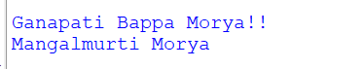

**B] Write a Python program to append text to a file and display the text.**

**Code:**

def create_file(filename):

file=open(filename,'w')

file.write("Modak :\nModak is considered to be the favorite sweet of the Hindu deity, Ganesha,\n and he is known as modakapriya(One who likes modak) in Sanskrit")

file.close()

def read_file(filename):

file=open(filename,'r')

print(file.read())

file.close()

def append_file(filename):

file=open(filename,'a')

file.write("\nDuring Ganesh Chaturthi, a puja usually concludes with an offering of 21 or 101\n modaks to Ganesha\nModak is easy to make and requires four ingredients: rice, maida or flour dough,\n coconut, and jaggery ")

file.close()

create_file('demo.txt')

read_file('demo.txt')

print("\n-------After perform append operation-------\n")

append_file('demo.txt')

read_file('demo.txt')

**Output:**

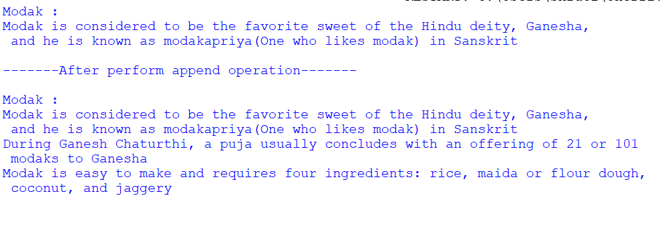

**C] Write a Python program to read last n lines of a file.**

**Code:**

def create_file(filename):

file=open(filename,'w')

file.write("Gulab jamun,Rasgulla\nRasmalai,Basundi\nKheer,ladoo\nKaju katli,Badam halava\nCake,Cookies")

file.close()

def read_file(filename):

file=open(filename,'r')

print(file.read())

file.close()

def read_last_line(filename,n):

with open(filename)as f:

print(f"\nlast {n} lines from the file are :\n")

for line in (f.readlines() [-n:]):

print(line,end='')

create_file('sweets.txt')

read_file('sweets.txt')

n=int(input("Enter n lines :"))

read_last_line('sweets.txt',n)

**Output:**

